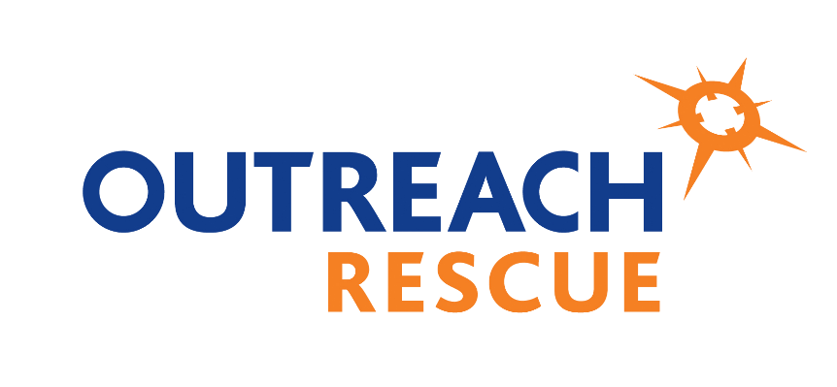
Outreach Rescue
Tan y Bwlch Centre
Llanllechid
Bangor
Gwynedd
LL57 3HY
Tel: 01248 601546
enquiries@outreachrescue.com
01-04-2022

Dear customer,
Due to the rapidly raising prices of energy, workforce and of domestic and commercial goods, we have had a pricing review of our services and have consequently increased our prices by 6% across the majority of our fixed price products.

The changes in prices come into effect immediately, with any existing bookings or outstanding quotes being honored at the price at the time of booking or enquiry.

We thank you for your understanding in this matter, and should you have any questions, please do not hesitate to contact us.

Kind regards

Greg Cain

Technical Training Manager

